# 

BRS for FinaMantic

(Hybrid)

Version: 1.7

Date:

**Table of Contents**

1. Project Goal 3

2. Scope of App listed user wise - 3

3. Project Process: 4

4. Foreseen Third Party Integrations & Plug-ins 4

5. Features (Scope of Work) 4

6. App Credential: 29

# 1. Project Goal

The goal of this application is to facilitate application users to take important financial discussions for committed couples. The app will help in keeping transparency between partners and the formulation of common goals so that the couple can use money to forge a shared vision of their financial future and potentially find financial services companies to help them execute that vision.

**Note:** We will be requiring the plaid api with any 1 banks api for ex: Wells Fargo or Bank of America credentials so as to do the needful integration and display the information in the application.

Below are the User Types in the application:

**User types**:

1. End-Users (mobile app): They are the user of the application who would like to know about their expenses by adding manually and later plan their financial goals.
2. Super Admin (web panel): admin will be able view all the registered users in the application and have an ability to enable / disable their account. .

# 2. Scope of App listed user wise -

User Capabilities:

1. Login - Manual
2. Sign up - Manual
3. 2-Step verification after login, through email OTP (optional)
4. Edit profile
5. Define goal
6. Manage goal on the basis of categories
7. Read chapters and prayers
8. Start exercise on the basis of chapter and prayer
9. Forget Password through email
10. Reset Password

Super-Admin Capabilities:

1. User management | App Users
2. Chapter management

# Project Process:

# Foreseen Third Party Integrations & Plug-ins

# Features (Scope of Work)

1. Users Screens:
2. **Splash:** This displays the splash screen of the application. This screen will appear when the user will open the App for the first time. The splash screen will also open after force killing the application and then restarting it.



1. **Access Contact:** Finamantic will ask user to access the contact list.
   * + 1. A pop up screen where app ask to access the contact list.
       2. Case 1: if it says yes then will move toward towards the login. Flow will be as:
          1. User click on “Access to contact”.
          2. All phone contacts sync with the application.
          3. App icon (Finamantic) will be visible against those contacts who are currently using this application.
       3. Case 2: If says no then it will display a message “to enter in app you need to access the contact

Soon after the Splash screen and pop up, by default the App will show the user the option below to login on the App. Following will be the screen;

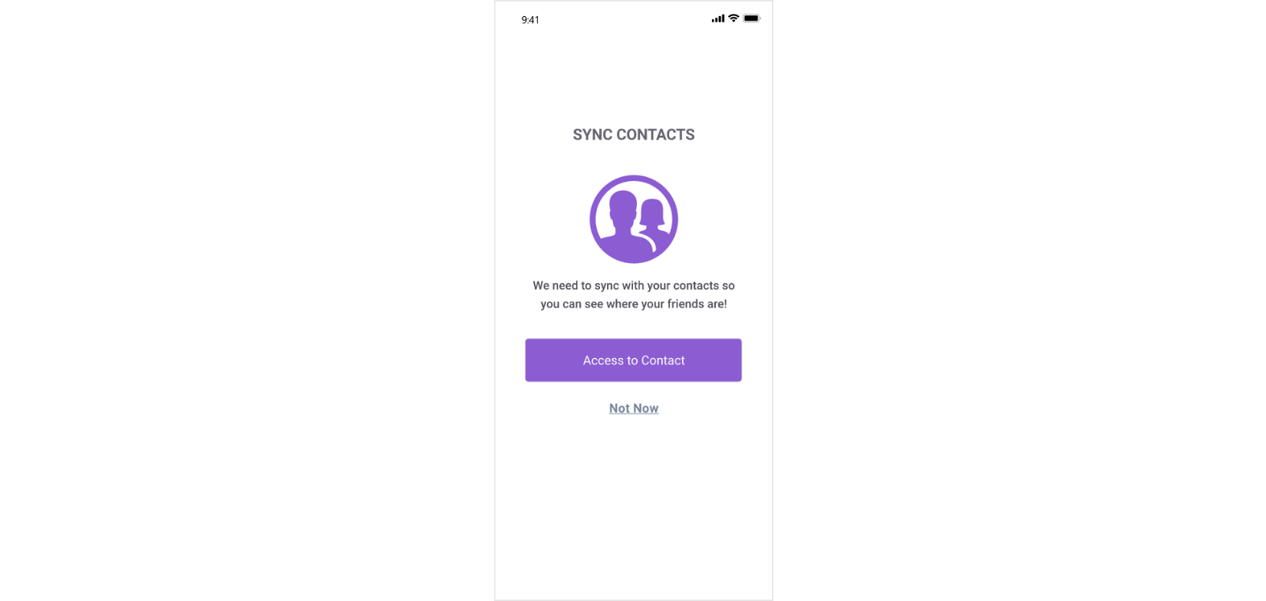 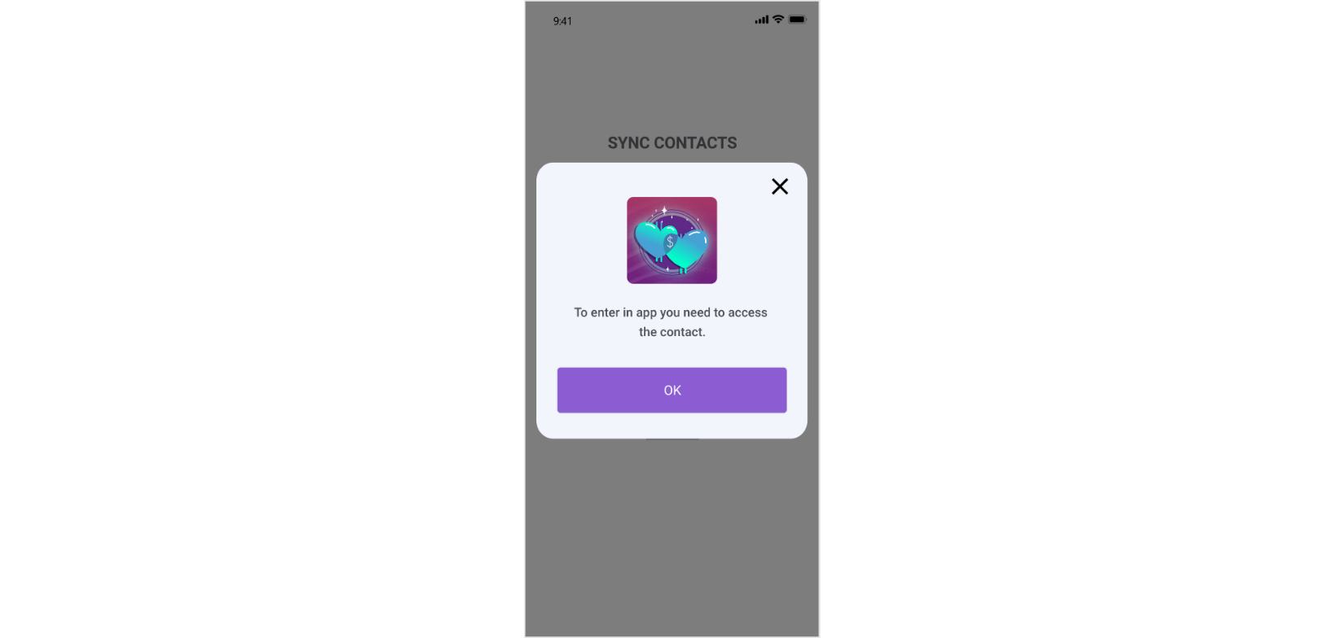

1. **Login:** Users can log in to their account using their mobile number/ email and password. Also, Users mark as remember the login details.

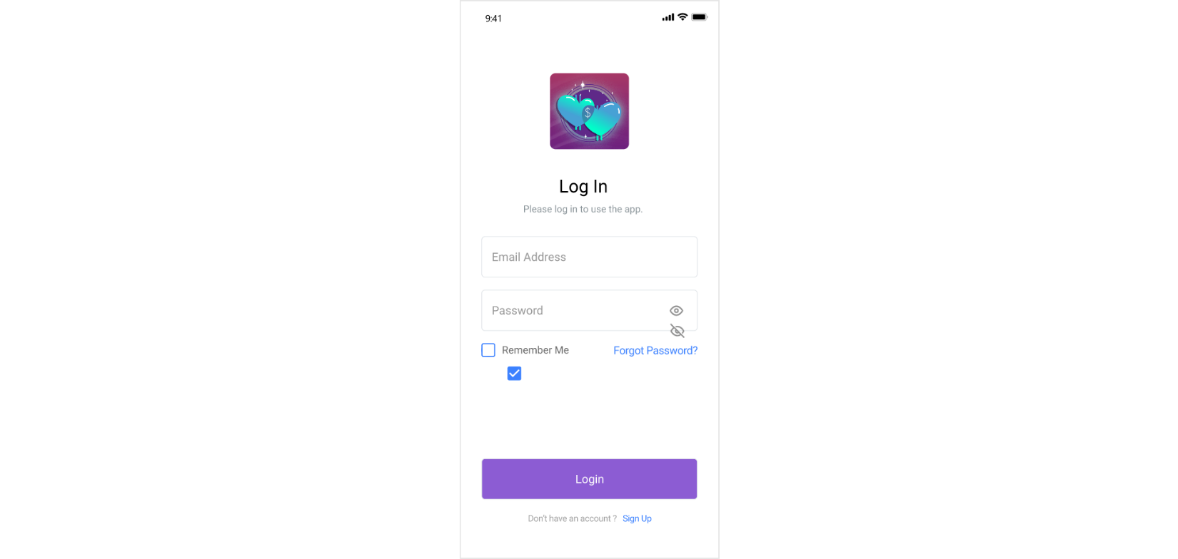

1. Logo
2. – Please login to use the app.
3. Email addrLine ess – Text Field (Unique ID)(Not editable)
4. Password – Text field
5. Remember me – Check box (check marked by default)
6. Login button - CTA for Login redirects User to home screen
7. Line – “Don’t have an account yet! Sign Up here” clicking on which will redirect to Sign Up screen.
8. **Forget Password:**

If user forgets their password, they will be able to click over the forget password and enter their registered email. This option will be available on login screen

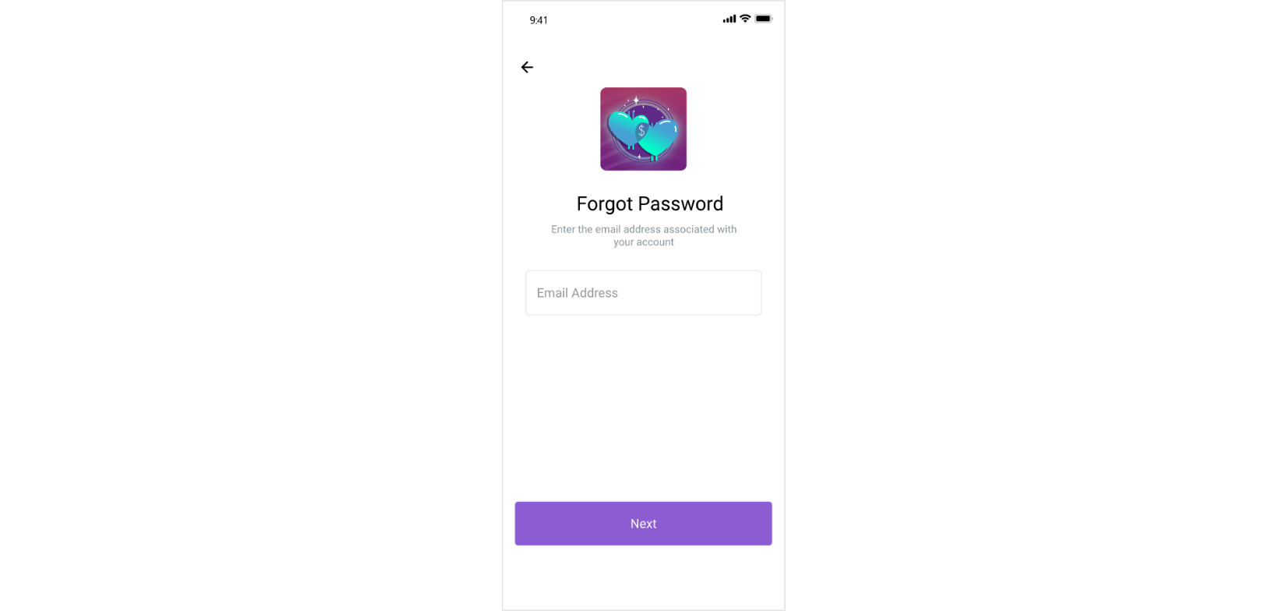

1. “Forgot your password? - Get help Signing in” - OTP to be sent to email. Elements of forgot password screen will be
2. Logo
3. Header text - Forgot your password?
4. Enter you email - Text field
5. Send button to send OTP on entered email address

**5. Reset Password**  
 The screen will allow the users to enter the OTP what they have received over their email ID

* 1. A 6 digit OTP Will be entered by the users
     1. Case1- resend OTP- Incase users did not receive the OTP then they can click over the resend button. This will be visible after 30 seconds after each attempt.
     2. Case2- Wrong OTP- Incase users will be enter the Wrong OTP, the app will show a message “Kindly enter the correct verification code” in red color letters.
     3. Case3-Correct OTP- Once the correct OTP will be entered by the users, A message can be seen “Correct” in green color and password and confirm password text fields will get enabled to create a new password.
  2. Password and confirm password: users can enter the password and confirm password (both are similar to the each other else it will not proceed).
  3. Once the password will be created, users will be redirected over the login screen to login back with new password.  
     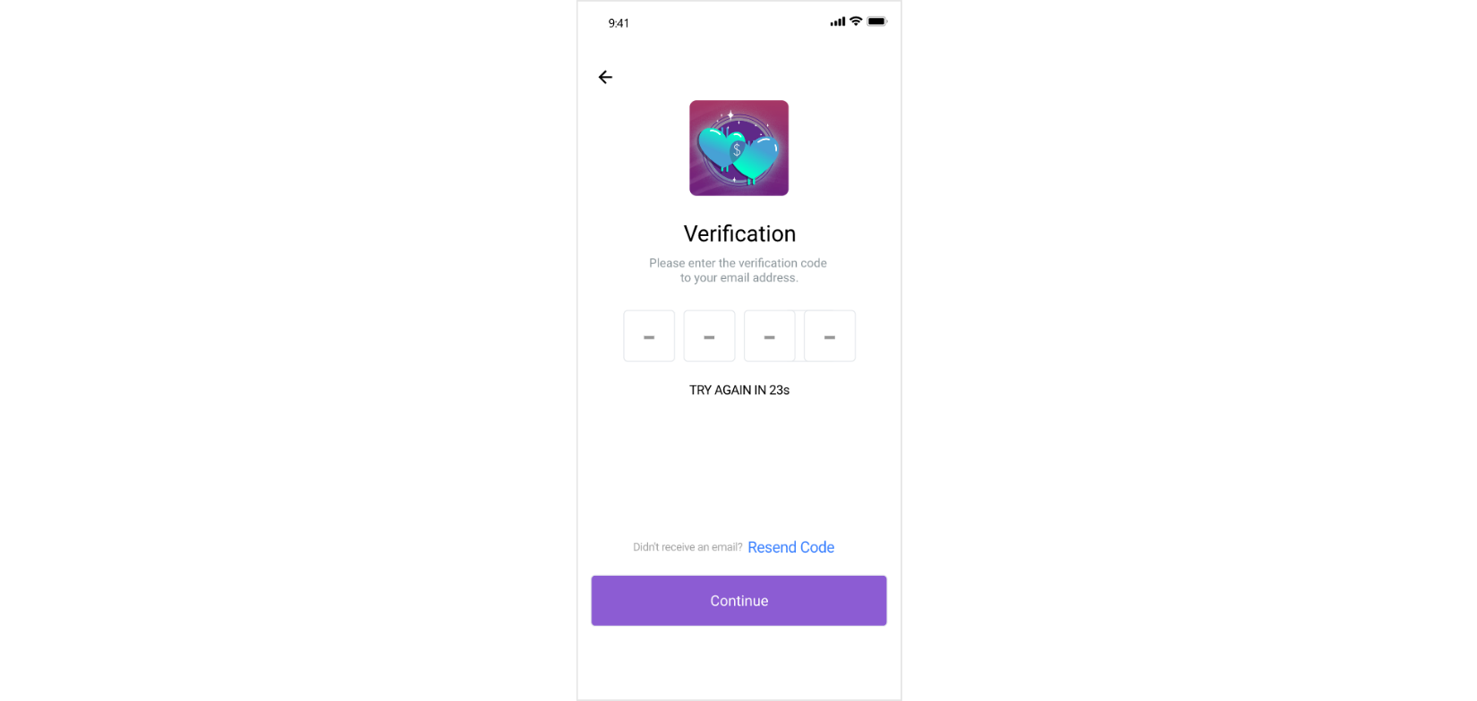 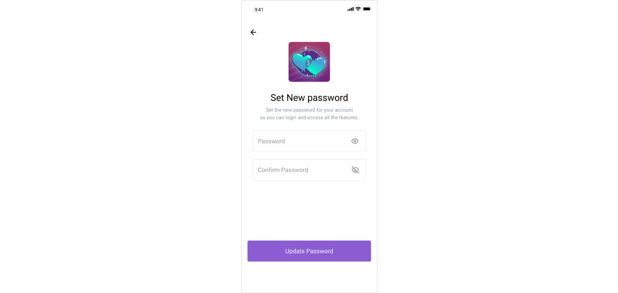

1. **Sign Up:** To register in the app user needs to do sign up. Refer the following screen

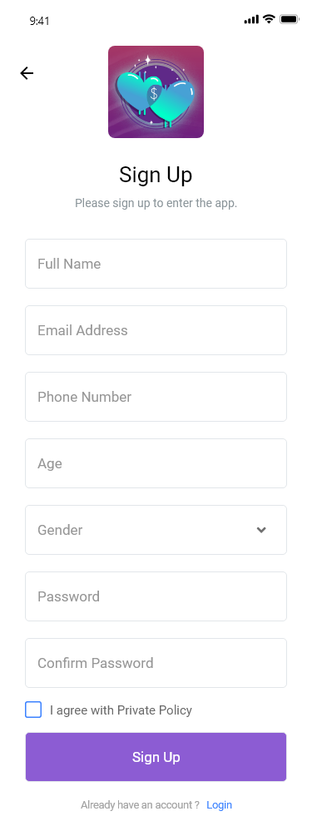

**Elements:**

* + 1. Logo
    2. Line – Proceed with your Sign Up
    3. Name -Text field
    4. Age (to work with filters)
    5. Email address – Text Field (mandatory)
    6. Password – Text field (mandatory)
    7. Phone number (non-mandatory)
    8. The gender (M/F/Others)
    9. I agree with Privacy Policy – Check Box Button (mandatory)(Check marked by default)
    10. Sign Up button - CTA for completing the process, redirects Users to completing their profile section for showing matches. Following will be the elements of the screen
    11. Login CTA - Already have an account. Login here, redirects user to Login screen

1. **Two factor Authentication:** The screen will allow the users to enter the email for verification purpose. OTP will be sent to the email address.

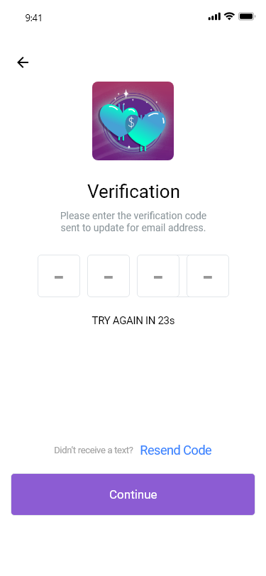

* 1. **Elements**
     1. Logo
     2. Header line – 2 Step Verification
     3. Text beneath – A text message with a 6 digit verification code was just sent to your email address.
     4. Blanks to fill in the 6 digit Verification Code
     5. Don’t ask on this device again – Radio button
     6. Didn’t get the code – Resend Code
     7. Button: Continue

1. **Home**

The home screen displays the expenditure made by user.

* 1. Total spent data: It will display the amount that user has spent from his account and the limit decided by them.
  2. Food/Housing/Other : It will display the total amount which user has decided and the bar on circle shows how much did the user spent
  3. Recent Expenses: these are the recent expenses made by the user.

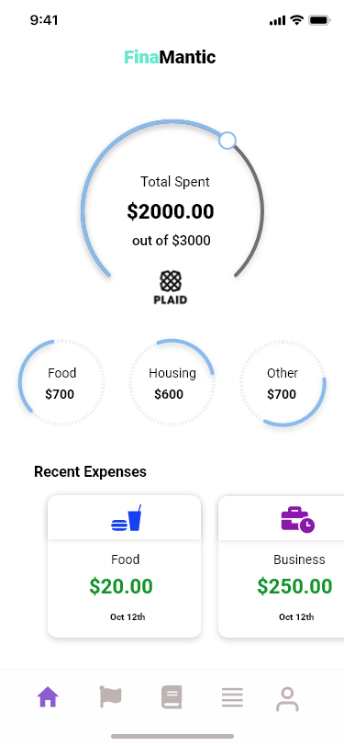

**Footer:**

* + - 1. **Home:** It will display the information as shown in the screen.
      2. **Flag:** These are the goals added by the user.
      3. **Book and prayers :** can be discussed in the following (section 15)
      4. **List of Expenses:** can be explain in following section (section 12)
      5. **Profile :** The user profile to view/edit the information

1. **Goal Category List**

User will be able to view list of all the added goals.

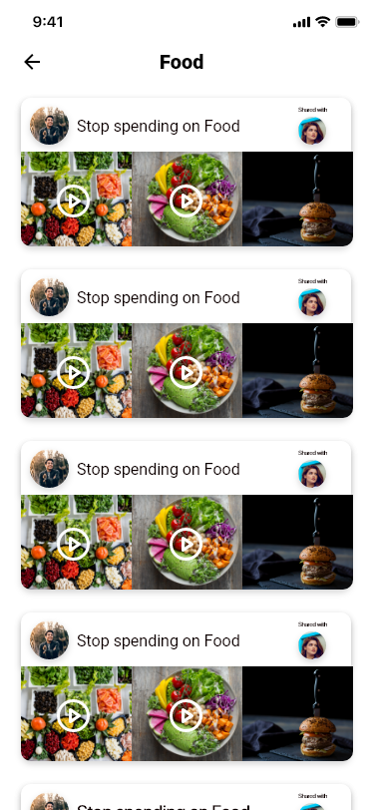

**Elements:**

1. **Heading : Goals**
2. **Goal List:** screen display the categories ( food, business, travel and so on) and goals set by the user in the application with category name, goal image (max 3) and person name and image with whom the goal has been shared.
3. **Plus icon:** It will help the users to set a new goal over the app as defined in point no. 13 (Add goal)
4. **Goal Listing Screen**

This will show all list of the goals in a particular category.

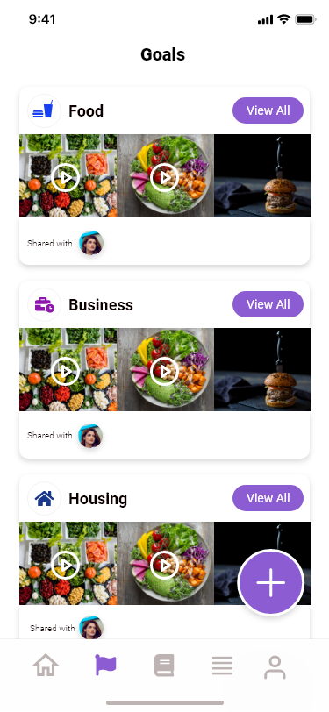

1. **Goal Detail:** screen display the budget allocated for the selected category.

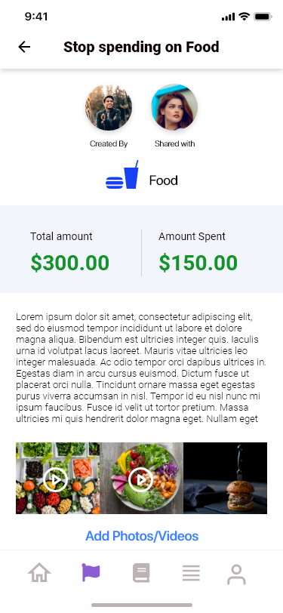

* 1. Thumbnail images: on the top of the screen user can see the category name and thumbnail of the goal creator and shared person.
  2. There should be 2 section :
     1. Total amount : The amount which is defined while making a goal
     2. Amount Spent: The amount left from the defined budget.
  3. Goal details and Amount: It will show the amount, title and description of the goal.
  4. Add photo/ video: it will display the photo added by the user.
  5. Progressive bar: which displays according to the amount in total and spent.  
       
     **Suggestion: It is better to assign a category in expenses.**

1. **Expenses category**The screen will allow the users to view all the expenses done on particular category which are created by the users such as food, housing, travel, etc.
   1. Users can select any of the category and can view all the expenditure of the respected category.

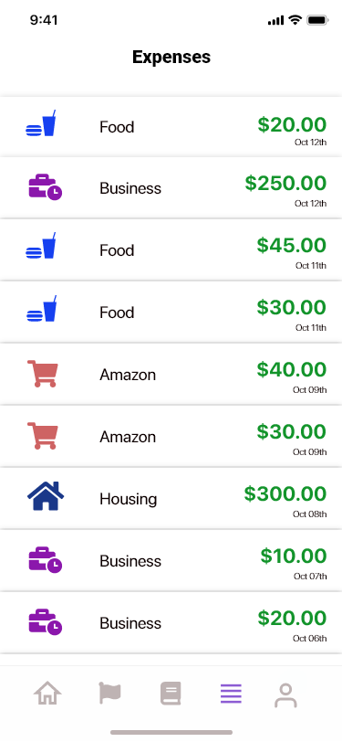

**Elements:**

1. Logo
2. Header Text : Category name
3. Left side thumbnail image : which is uploaded by the user from the gallery section
4. Expense name 1
5. Date
6. Amount
7. **Home – 1 (Expenses)**Screen will be visible after selecting the category. Kindly note that the category information will be dependent on the Plaid api. In case we do not receive the information as per the below screen from the plaid api then we have to update this screen accordingly.

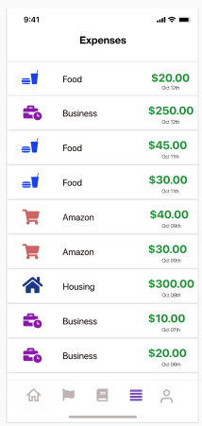

* 1. It will show the list of all the expenses with name, image, icon, date, and spent amount.
  2. The attached screen is showing all type of expenses of all the categories. There should be only one category’s expense.

1. **Add goal:** It will help the user to add a goal.
   1. Header: Add Goal
   2. (<): it will redirect to point 9
   3. Goal Title: allow user to enter the title of goal.
   4. Budget: allow user to enter the budget of goal.
   5. Goal description: allow user to enter the description of goal.
   6. Share with: allow user to select an application registered user to share the goal. Users can search any of the registered users over the app after typing his/ her name (It can be a single or multiple users) in the text field and can add them.
   7. Category: It will be a dropdown to select expense category such as housing, food, etc.  
      Note: Food goals can be merged when created in the same category. E.g. spend less on coffee and more on bread.
   8. Plus icon: allow user to add photo/ video from their gallery. (One media file at a time).
   9. Add goal: It will help the user to submit the goal in the application.



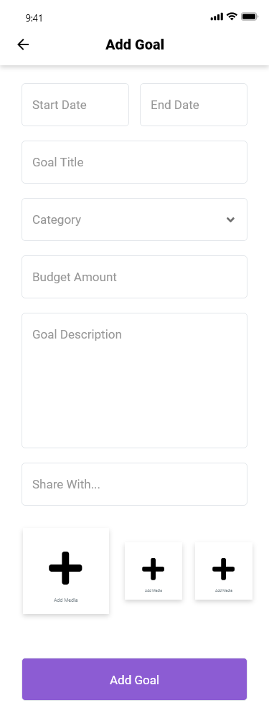

1. **Invite partner:**Once users click over the share with, the app will ask to access the contact list of the mobile phone. Users can invite the users after selecting over any of the contact
   1. **Case-1 (Already exists):** If the partner is already exists, it will send a notification to the selected user. Once partner will click over the notification, the goal will be opened automatically.
   2. **Case -2 (non-existing user):** If the partner is not on the app, users can invite the partner after entering the name and email.
      * 1. The system will send an invite request to the partner with a message “Partner – ‘A’ has invited you to view the goal” and goal view URL.
        2. Once users click over the URL, the app will navigate the users to PlayStore/ iTunes Store to download and sign up over the app.
        3. Once the signup will be done by the users, they will be redirected over the goal screen.
        4. The invitee will be notified, once the goal will be joined by the shared partner.

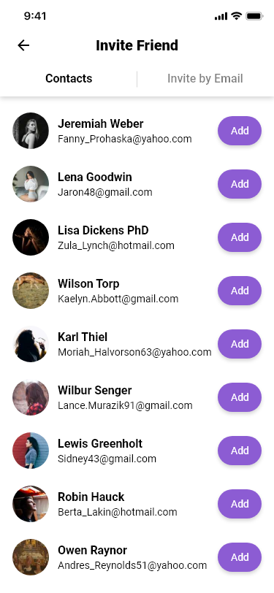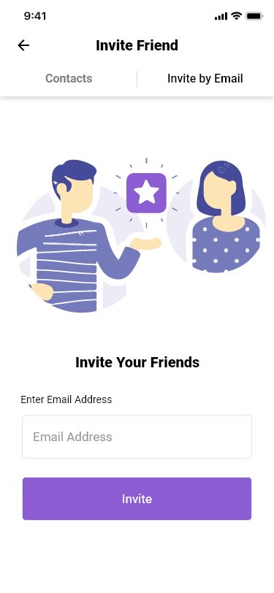

1. **Books & prayers:** It will show all the financial chapters along with prayers with the questionnaire and answers concluded with the chapter
   1. Your answers: It will show the list of all the chapter’s answers
      * 1. Chapter1: It will navigate the users to show all the answer for the question which are entered by the users in respect to the chapter.
   2. Partner’s answers: It will show the list of all the partner’s answers on the basis of each chapter.
      * 1. Chapter1: It will navigate the users to show all the answer for the question which are entered by the partners in respect to the chapter.
   3. Book chapter: It will show list of all the chapters
      * 1. Chapter1: It will navigate the users to show the content of the chapter.

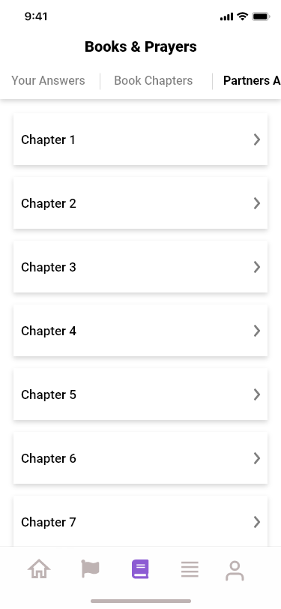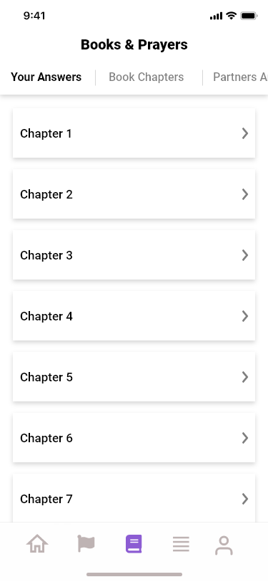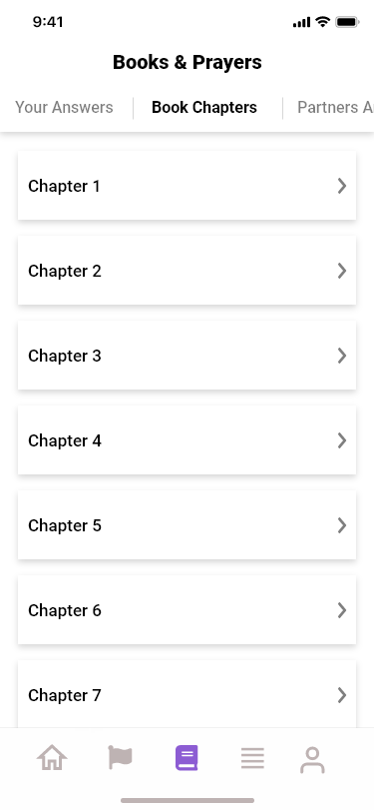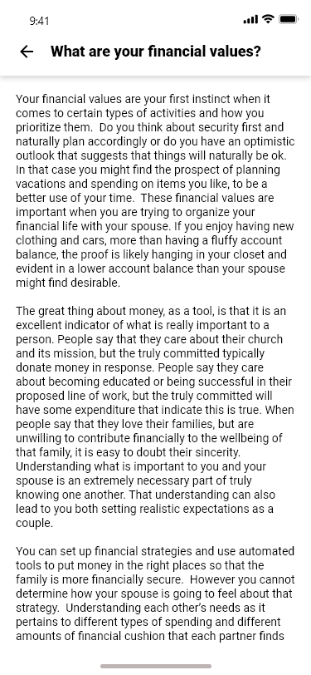 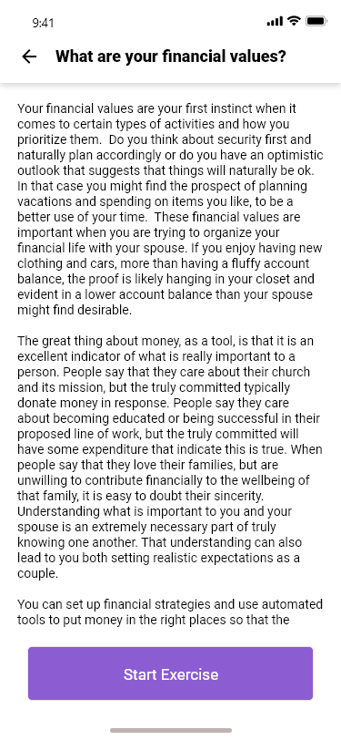

Start exercise: clicking on this button will navigate user to next screen.

1. **Question Screen**It will show question related to the chapter as added by admin with the options to select.
2. Following format (days/weeks)
3. Descriptive Format
4. Button :Select

The option will be same for all the questions added by admin.

* 1. Days of the week: It will checkmark option where use can select the days of the week (M, T, W, Th, F, Sa and Su).
  2. Time of the day: it will allow user to select the day time. Only one time will be set.
  3. Subject of prayer: allow user to enter the prayer subject.

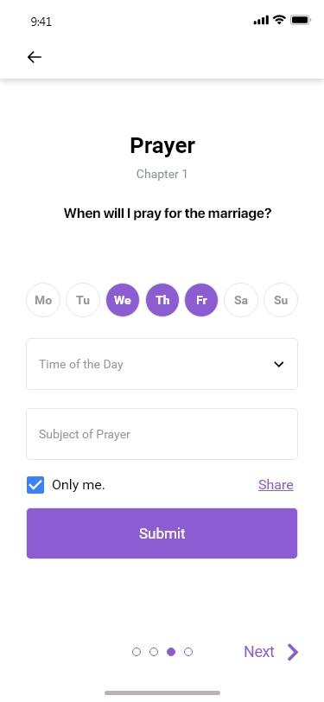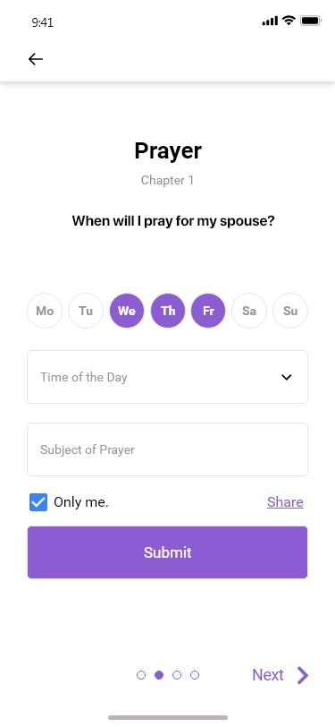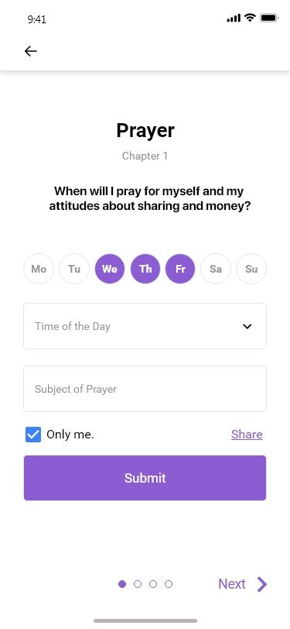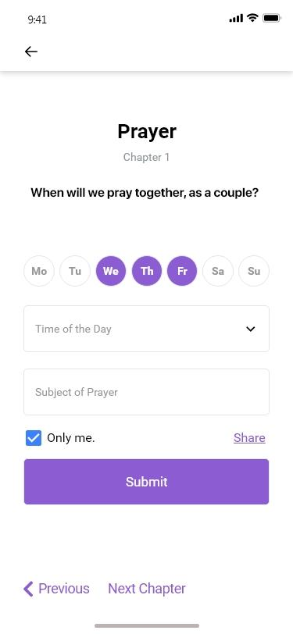

**Elements:**

1. Heading (Prayer )
2. Sub Heading Chapter 1
3. Question ( as displayed in screen)
4. Next and previous arrow: It will navigate the users to the next or previous set of question. The options for each question will remain same.
5. **Question Screen**It will show next set of question.
   1. Next arrow: It will navigate user to the previous set of question.
   2. Next chapter: Clicking on the next will navigate user to the next chapter.
   3. Only me: If users don’t want to share their goal with anyone then they can click over the only me.

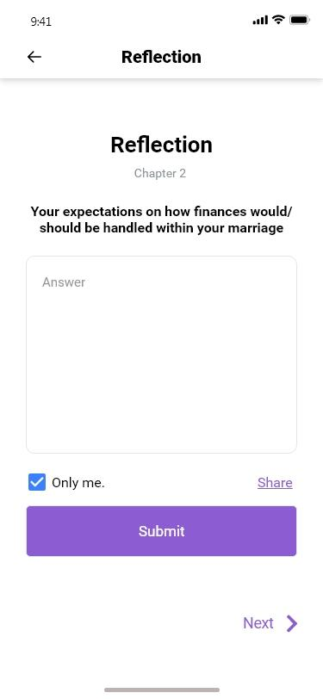

1. **Share**The screen will allow the users to share the answers/ prayer time after selecting the partner. Once users click over the share with, the app will ask to access the contact list of the mobile phone. Users can invite the users after selecting over any of the contact
   1. Case-1 (Already exists): If the partner is already exists, it will send a notification to the selected user. Once partner will click over the notification, the shared answer/ prayer will be visible. (this will be done by deep linking)
   2. Case -2 (non-existing user): If the partner is not on the app, users can invite the partner after entering the name and email.
      1. The system will send invite request to the partner with a message “Partner – A has invited you to view the answer/ prayer” and shared answer/ prayer view URL.
      2. Once users click over the URL, the app will navigate the users to PlayStore/ iTunes Store to download and sign up over the app.
      3. Once the signup will be done by the users, they will be redirected over the answer/ prayer view screen.
   3. The invitee will be notified, once the shared answer/ prayer will be joined by the shared partner.
2. **Chapter Screen**: Screen display the content of the chapter as added by admin from the backend admin section**.**

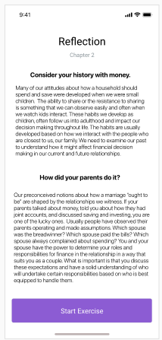

1. **Reflection Screen** It will show the title of the question and users can answers over that in descriptive format.



**Note:** Text limit for the answer would be 100 words and multiple choices questions to be available in the admin.

1. **Answer Screen**

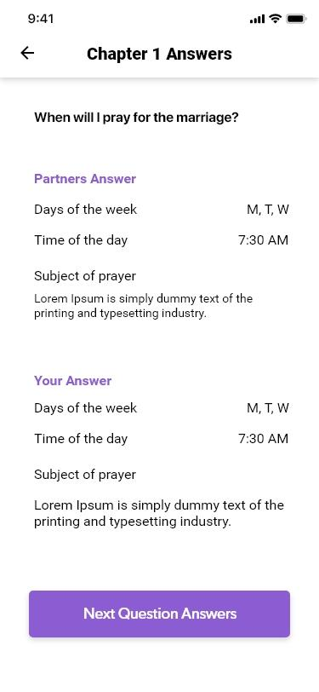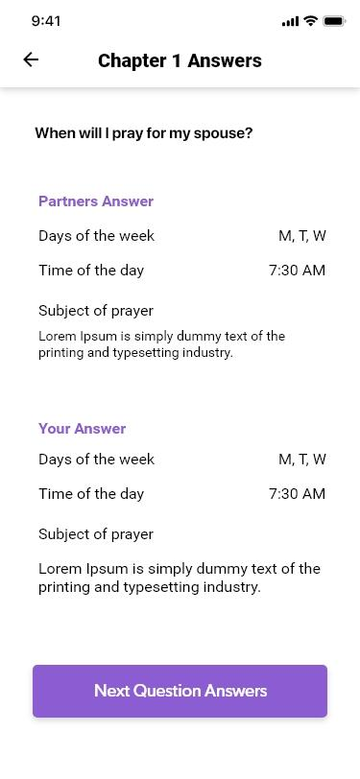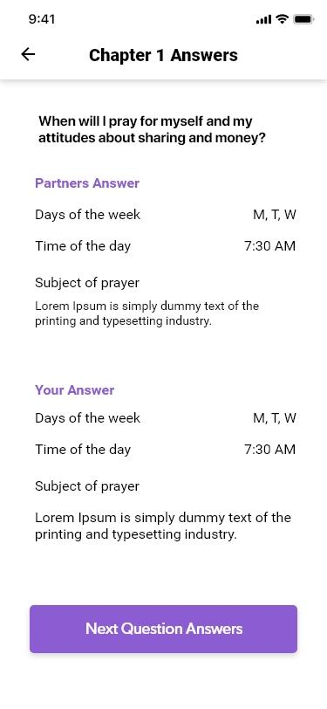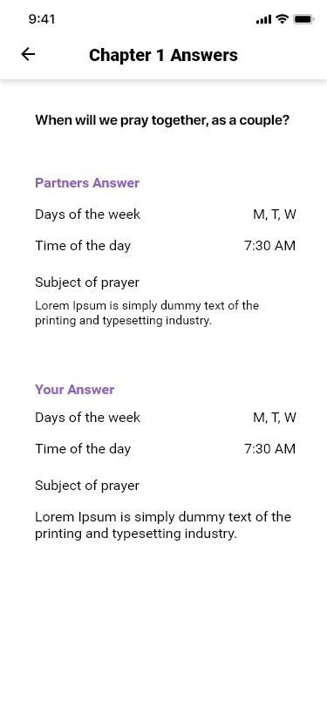

1. **Profile :** screen displays the profile information as added by user includes its name, profile pic and email.
2. The screens will to get into the settings screen where user will can change the settings they want in the application.
   * + 1. Privacy policy & Terms and condition: It will display the privacy policy as added by admin from the web admin panel.
       2. Change password ( section 27 )
       3. Log Out

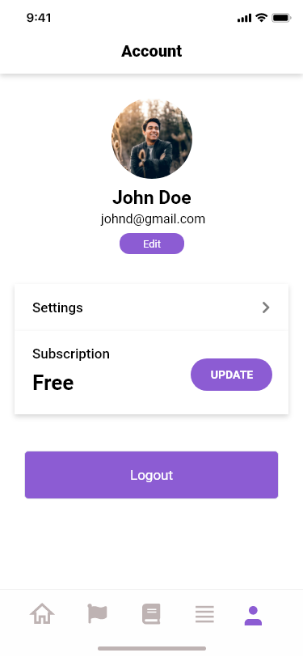

1. **Edit Profile: screen allow user to update their profile information**. Kindly note that email will not be editable. User will be able to update their display name, change photo, and update their phone no.  
   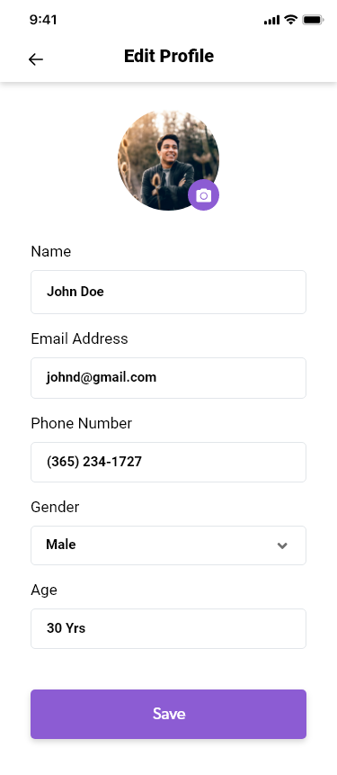

**19. Notification**

**20. Settings**

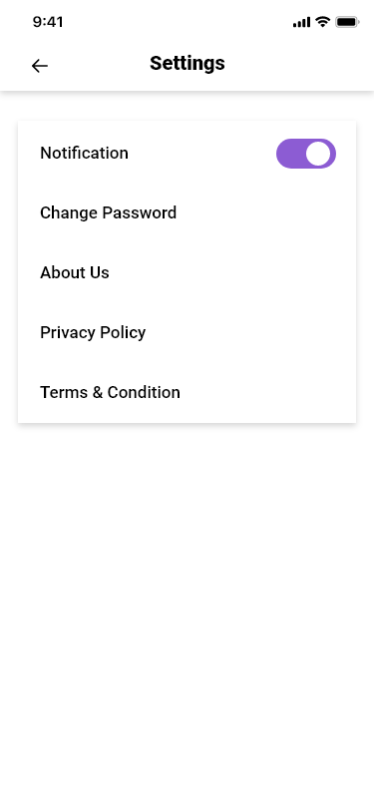

**21. Change password**

1. Button – Change Password: The user can change their password if they want, it will take user to the reset password screen and they would need to click on the reset password, so that the OTP can be sent on the email Id to change the password.
2. Save – Button – The user once click on the save button will allow user to save their details in the application. Then the saved or updated profile can be seen by the user themselves

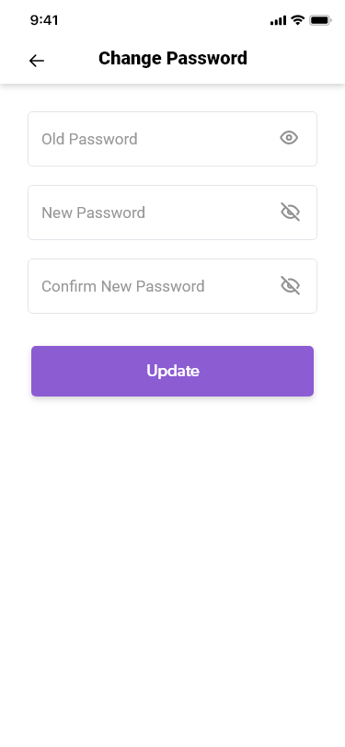

**22. Privacy Policy**

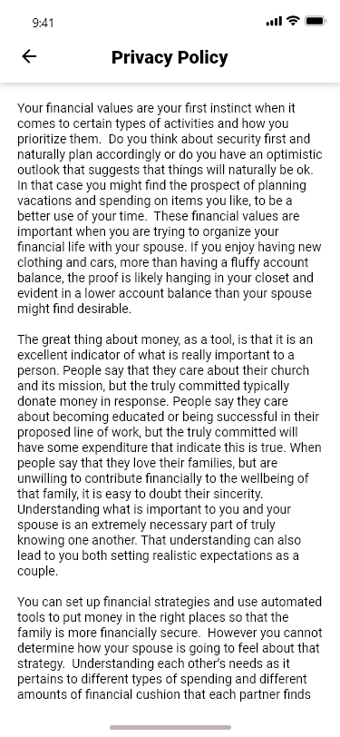

**23. Terms & Conditions**

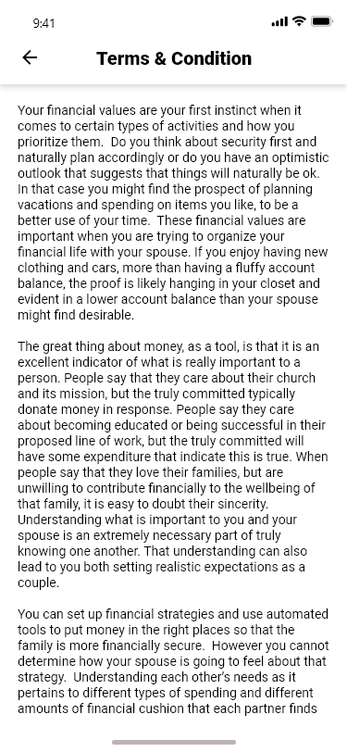

**24. About Us**

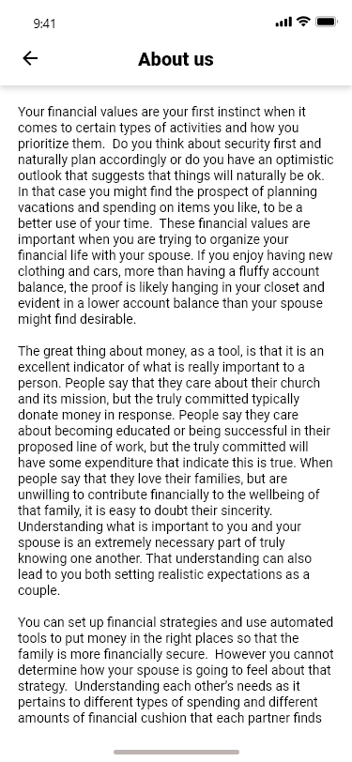

**Subscription**

* 1. There will some certain limitation to add goals such as 10 Goals, once users will reach at this number of goals, the system will ask to purchase the premium version of the account to save the unlimited goals over the app.
     1. Subscription price will be decided by the admin.
  2. The payment would be made via in app purchase.  
     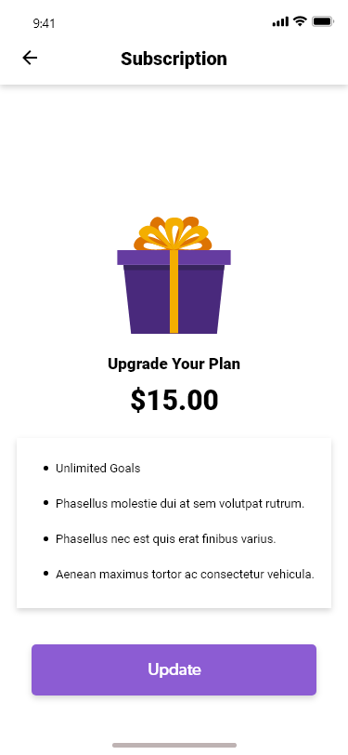

1. Super Admin web-panel:  
   Admin will be able to log in over the platform by provided Users name and password
2. **Users management**
   1. Admin will be able to view a list of all the registered user in the application
   2. Admin will be able to enable/disable any user's account.
3. **Add Chapter**
   1. Add Chapter: to add a chapter admin will enter below information

A. Chapter title

B. Chapter No.

C. Chapter detail

* 1. **Add/delete question**

Select Answer format: Only one format can be selected for a question.

1. Only text format

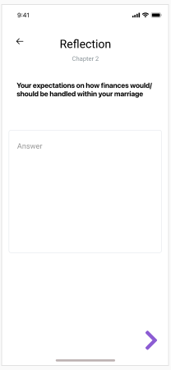

B. Allow user to add (days of the week, time of the day and subject of the prayer)

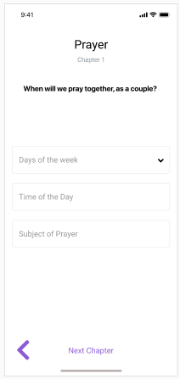

# App Credential:

Client to share below credentials while approving the document.

| S. No. | Description | Users name | Password |
| --- | --- | --- | --- |
| 1 | Server hosting details |  |  |
| 2 | Apple store account login details |  |  |
| 3 | Duns Number with Company Account |  |  |
| 4 | Google Play Store credentials |  |  |
| 5 | Send grid details |  |  |
| 6 | Domain details |  |  |

Please feel free to contact us for any queries. We would be happy to discuss over the BRS in detail. Thank You!

**☺--- END OF DOCUMENT ---☺**